Assignment 18.
- What's the use of header line demonstrate with one program.
- It is an obsolete implicit work area for an internal table that shares the same name as the table body
- When you declare an internal table with a header line, the system automatically creates a work area (a single-row buffer) with an identical structure and name.
- Purpose: The header line temporarily holds a single record when you read data from the internal table or prepare a record to be inserted, modified, or deleted.
- Both the table body and the work area have the same name.
- 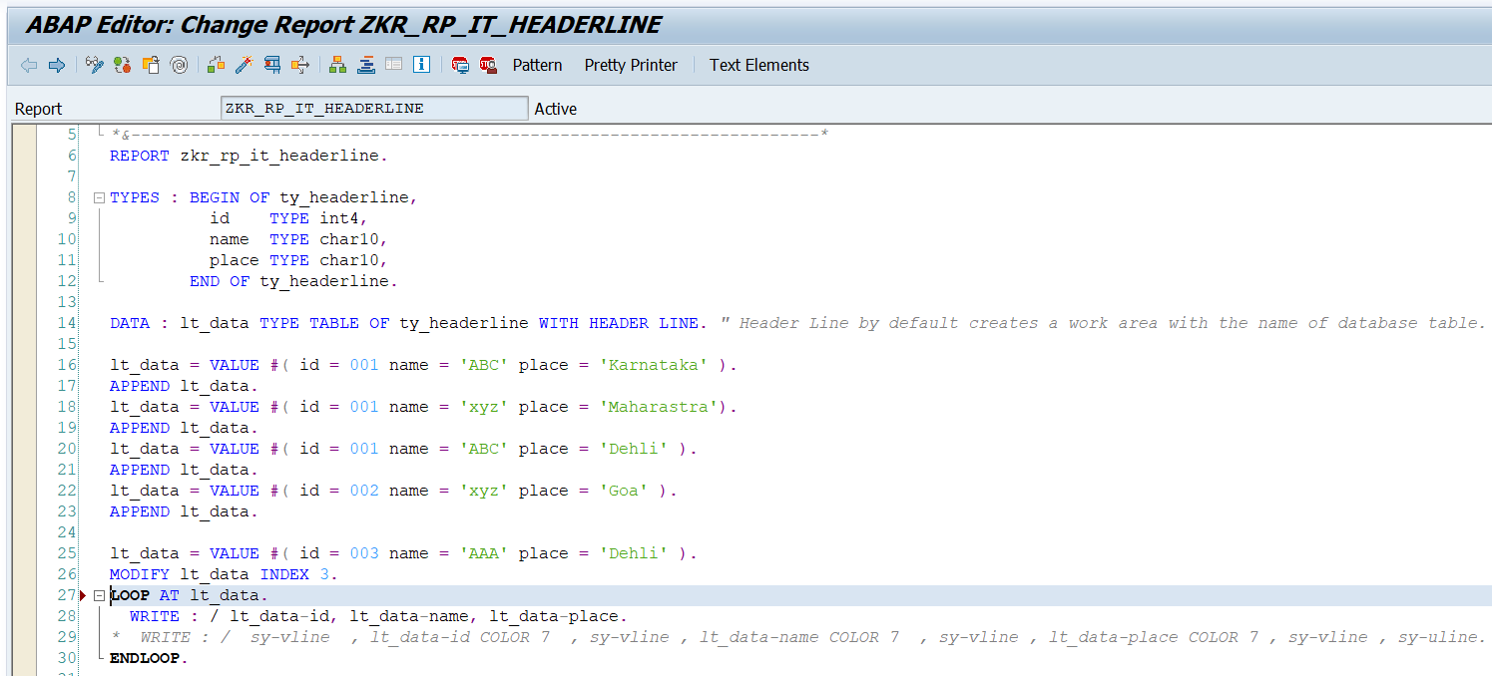
- Output:
- 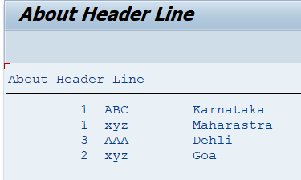

- How change the specific field value demonstrate with example
- We can change the specific field value by using MODIFY statement.
- 2 ways in modify, 1. MODIFY by INDEX and 2. MODIFY by KEY/ID.
- Before changing the output:
- 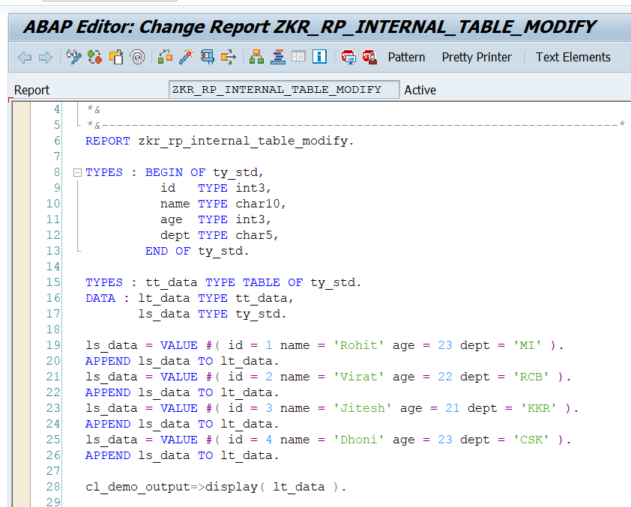
- Output:
- 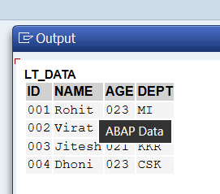
- After changing the output:
- 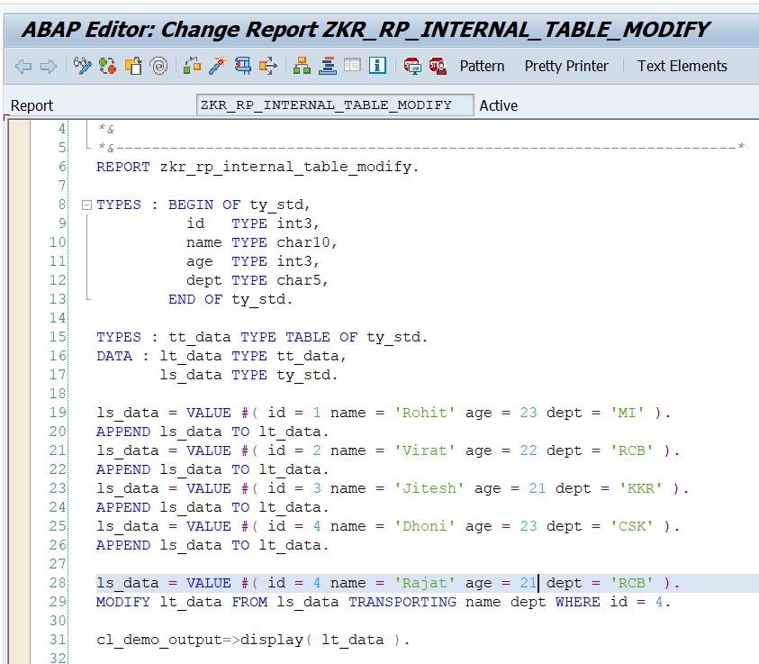
- 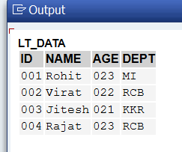

- How to find 'n' no of records present inside Internal Table.
- We can find ‘n’ no of records in internal table by using DESCRIBE TABLE.
- Find the number of records in an internal table are using the built-in function LINES ().
- 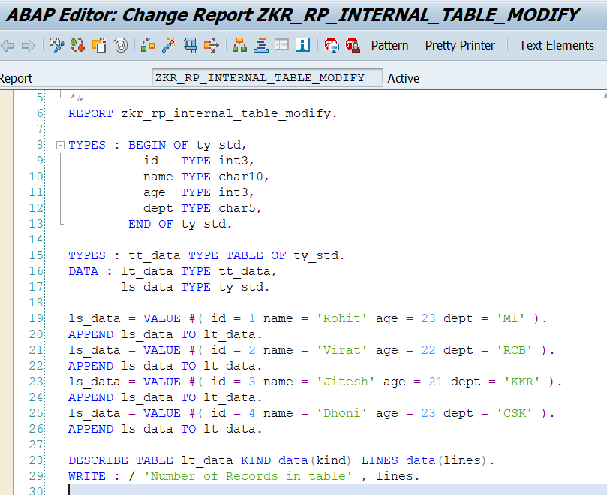
- Output:
- 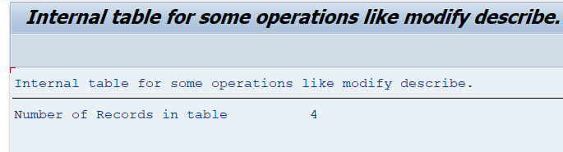
- Work on Collect statement, Adjacent Duplicate & Deleting specific records from IT.
- Collect statement:
- COLLECT inserts a row into an internal table. If a row with the same key already exists, ABAP adds numeric fields instead of creating a new row.
- 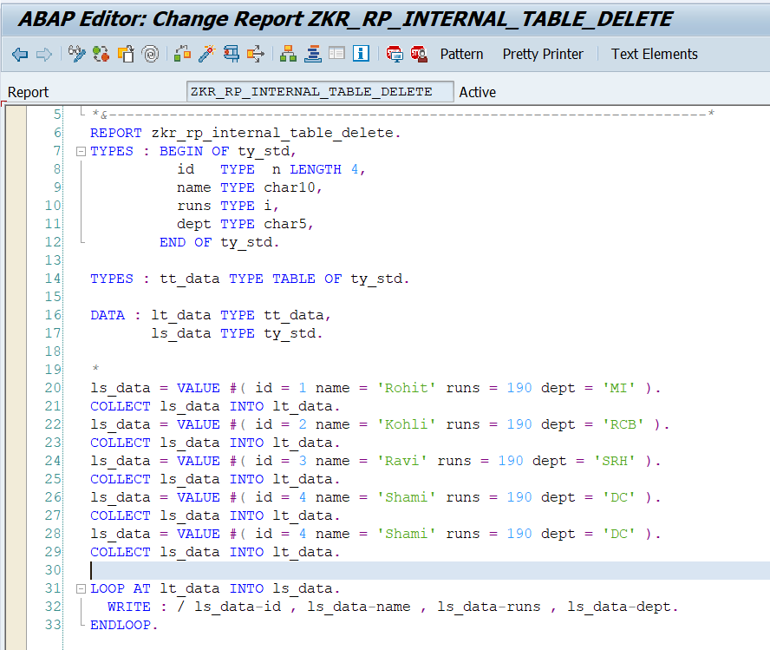
- Output:
- 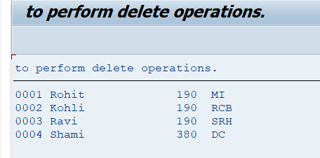
- Id 4 is added the runs 190 + 190 = 380 so COLLECT statement add the numeric values if the fields data is same.

- Delete adjacent duplicates:
- 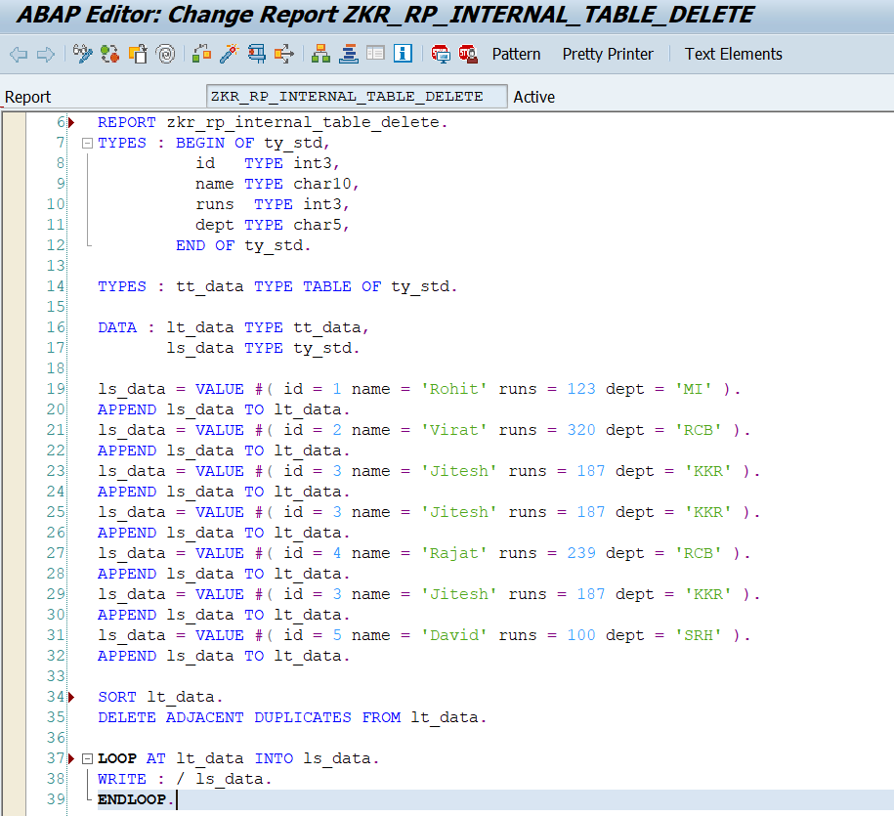
- Output:
- 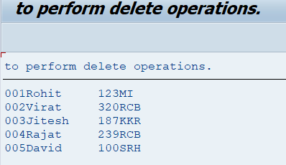
- Deleting a row:
- 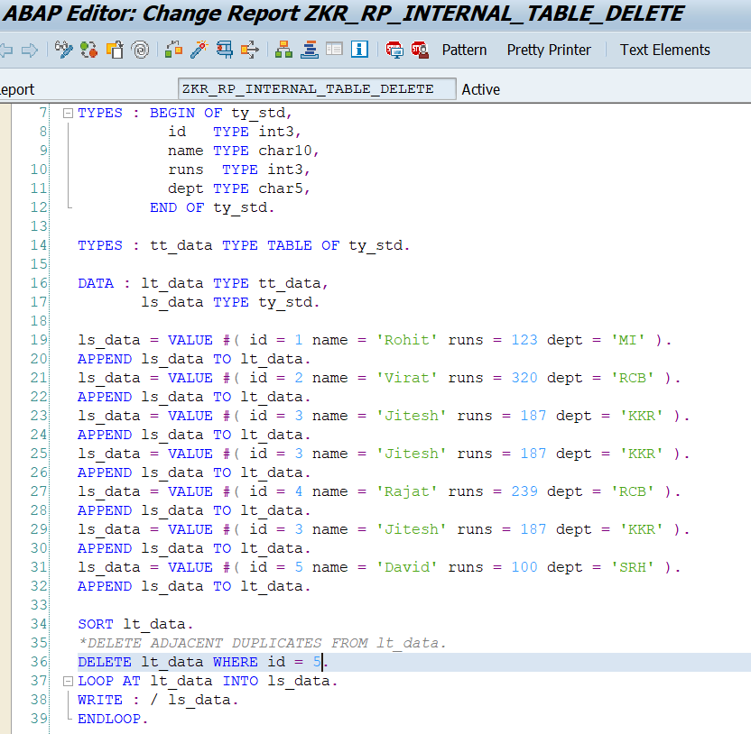
- Output:
- 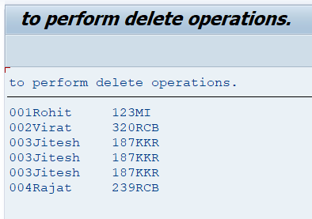

- primary key and secondary key with example.
- A Primary Key is the main key of a table that uniquely identifies each record.
- A Secondary Key is an additional key defined for an internal table to improve search performance.
- An additional key used to access data faster without changing the primary key.
Feature | Primary Ke | Secondary Key
Purpose | Identify record uniquely | Faster searching
Uniqueness | Unique | Can be unique or non-unique
Number allowed | One | Multiple
Usage | Database and internal tables | Internal tables
Mandatory | Yes | Optional

- Primary key and secondary key for standard, sorted and hashed tables.
- 1. For Standard table:
- Program:-
- 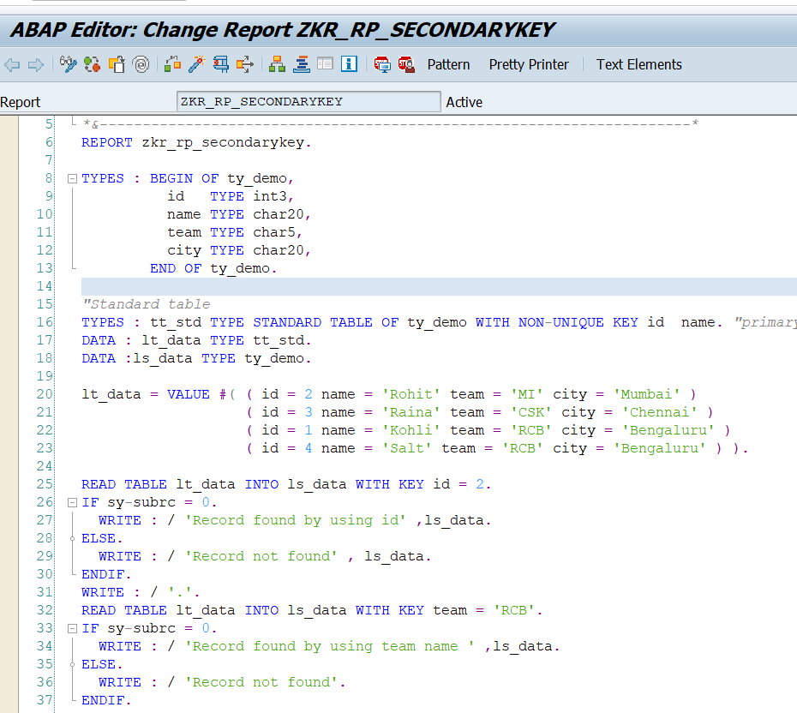
- Output:-
- 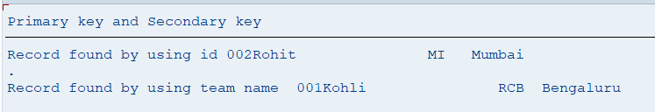
- 2.For Sorted Table:
- 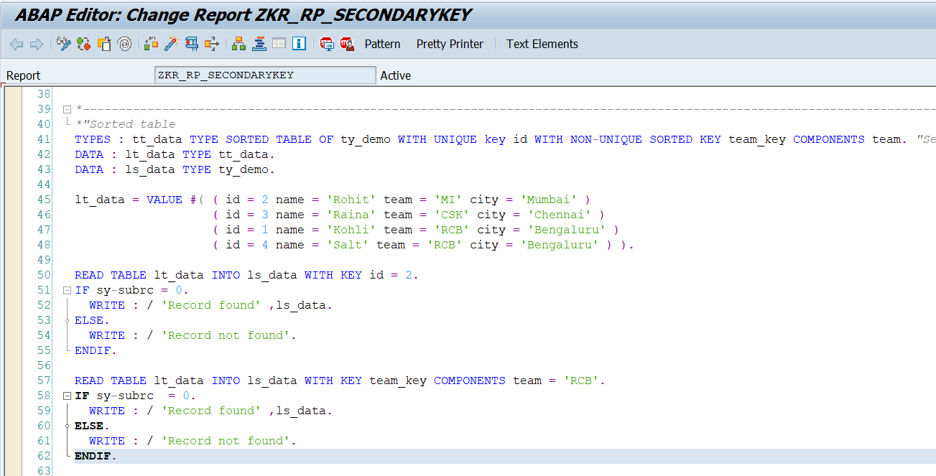
- Output:-
- 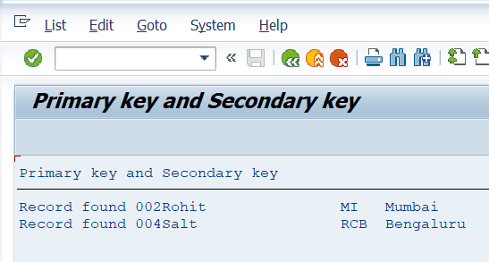
- 3.For Hashed table:
- 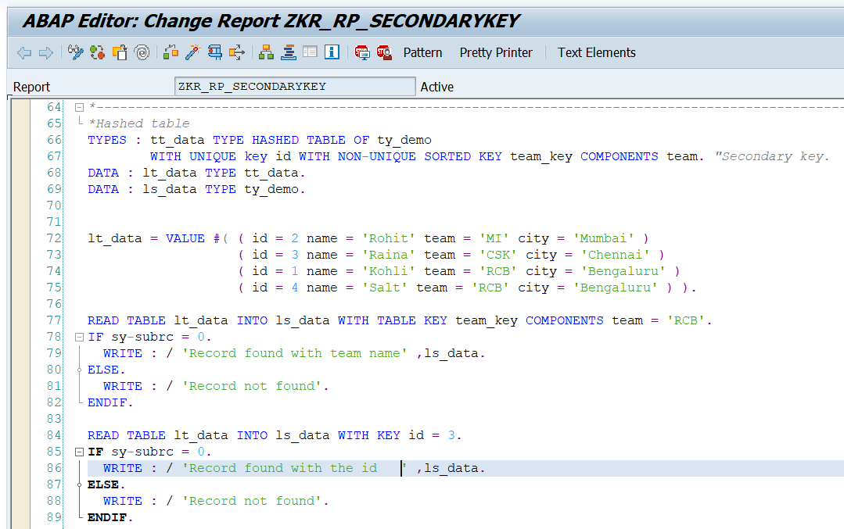
- Output:-
- 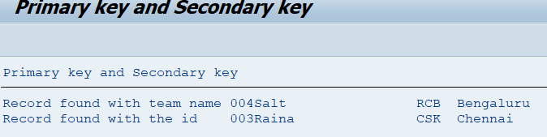

- Condition Statements.
- Parameter, IF, ELSE, ELSEIF, CASE:
- Parameter: Used to take Input from user.
- 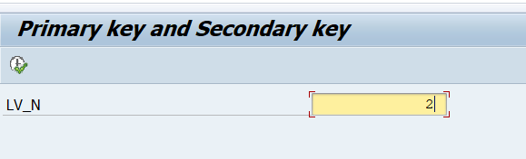
- If else, elseif (Nested if):
- 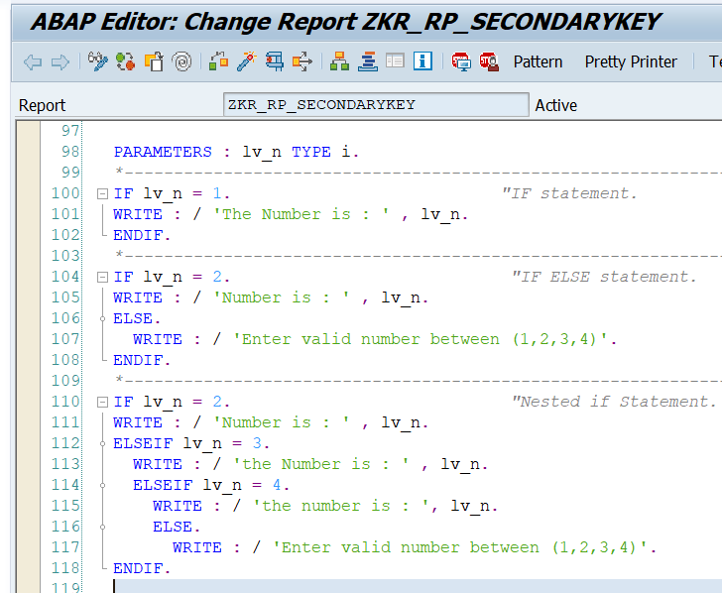
- When we execute the program input screen will be appear and after entering the input the logic is performed.
- 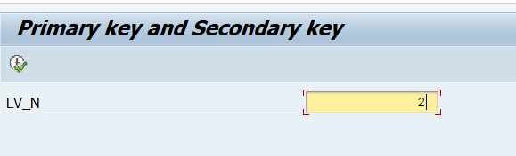
- 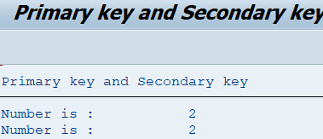
- CASE Statement:
- 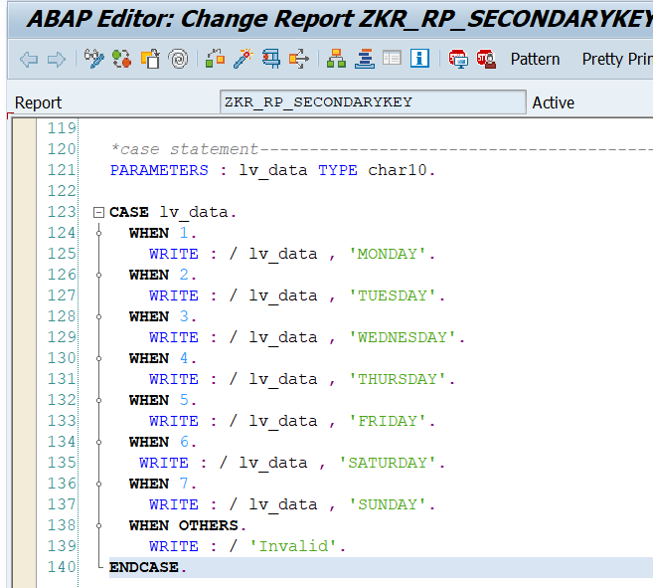
- Output:
- Input screen will be visible (parameter).
- 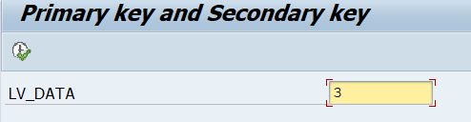
then, execute.
- 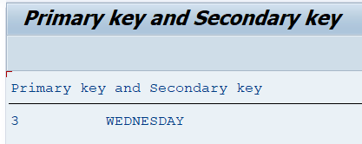

COND statement:
- It is a conditional operator used to define an expression that returns a value based on one or more conditions.
- COND is a conditional expression used to assign a value to a variable based on conditions, similar to IF–ELSE.
- 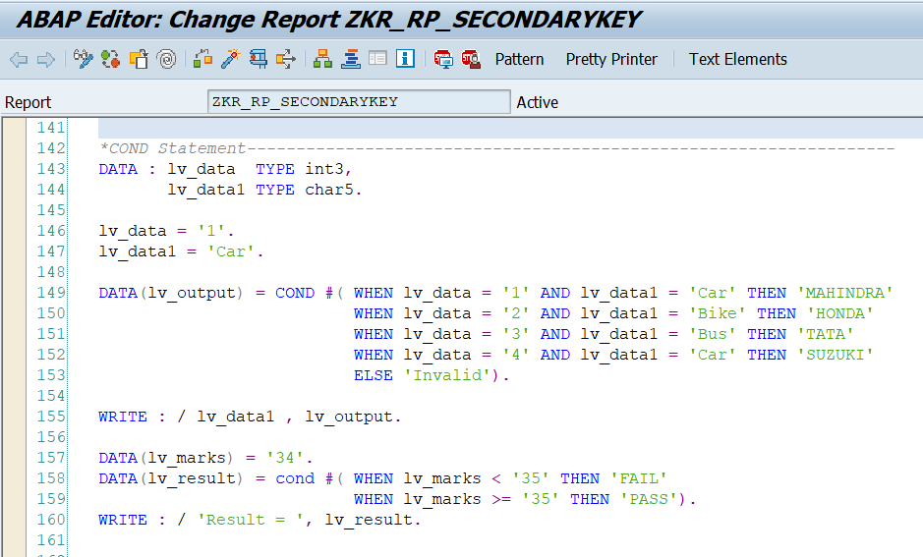
- Output:
- 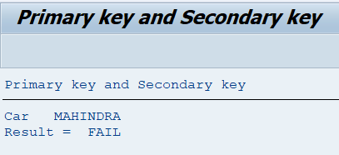
SWITCH Statement:
- SWITCH is used to assign values based on a specific variable value, similar to CASE statement.
- a conditional operator used to assign a result based on a case statement.
- 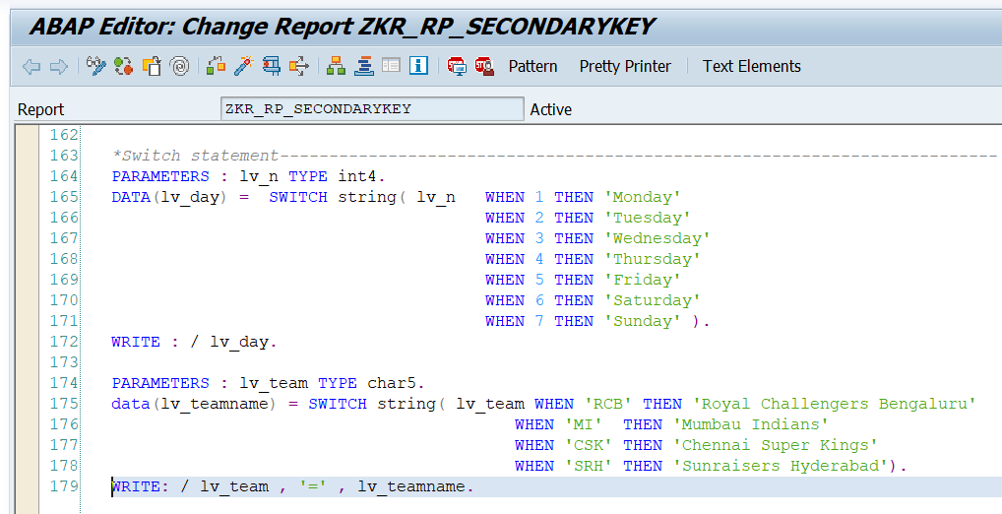
- Output:
- 